**Background Research**

By: Michael Scott, Armend Eduard, Ryan Stone, Chay Wilson, Felix Manyme & Taryn Mackenna

Contents

Introduction 3

The Current Problem 3

The History of the Problem 4

Relevant Physics/Engineering 5

Power Generation 5

Managing Sensors 6

Wi-Fi Connectivity 7

Electrical compliance and cable management 8

How will we work with other subsystems? 8

Conclusion 9

References 10

# Introduction

## The Current Problem

Spa park is located at Bela-Bela in Limpopo South Africa. Bela-Bela means “boiling boiling” in Tswana language. The name was derived from the abundant hot springs in the region. These springs are treasured by local indigenous groups for their medicinal abilities, and they have attracted visitors from a variety of backgrounds over the years. Today, Bela-Bela exemplifies the beautiful blend of history, culture, and natural beauty that defines this exceptional location​ (Mbizi game lodge, 2023)​.

Hydroponics is a novel concept in Bela-Bela, indicating a lack of awareness or adoption among the local populace. While its potential benefits are acknowledged around the world, its incorporation into agricultural methods in this country has yet to be extensively understood or adopted​ (Mchunu, et al., 2018)​.

Moreover, introducing hydroponics to Spa Park Primary School represents a new challenge. Many students are unfamiliar with this approach of growing plants without soil; thus, this project will challenge traditional food practices. Addressing ingrained cultural norms and preferences about food consumption and production in the Spa Park Primary School community. This problem involves navigating cultural sensitivities and encouraging openness to alternate, more sustainable food practices.

Load shedding is a prevalent issue in South Africa, and Spa Park is no exception to the challenges that occasional power outages bring to the operation of sustainable food initiatives such as hydroponics​ (Erchen, 2023)​. Addressing this challenge will involve developing strategies to avoid disruptions in food production and maintain system functionality during periods of reduced energy availability by researching alternate energy sources such as solar power.

## The History of the Problem

Hydroponics is a process of growing plants without soil- all you need is water, nutrients, and a growing medium. Unlike soil, the growing medium does not absorb water while still providing root support & oxygenation. As a result, hydroponics' major benefit is using much less water than traditional growing methods​ (Espiritu, 2023)​.

Hydroponics is an ancient practice, with one of the first examples being the Hanging Gardens of Babylon in the 6th century BC. From there, the process would evolve and become more technical. The modern hydroponics process was invented by William Gericke in 1929​ (Espiritu, 2023)​. The small footprint and low water consumption makes Hydroponics an attractive growing process for both commercial operations and hobbyists alike, especially in urban environments where access to growing land is limited.

Modern technology has been a boon for the hydroponics industry. Sensors to measure and control moisture, water flow, nutrient infusion, lighting, and more have simplified & reduced the burden on growers, making hydroponics even more accessible to the public​ (Saha, 2022)​.

These sensors lie at the heart of Team 2’s problem. Our goal is to make an efficient electronics package that meets the needs of the other two teams and integrates cleanly into the overall system. South Africa is currently in an energy crisis and is practicing “load shedding”, or scheduled blackouts to reduce power demands on their electric grid​ (Erchen, 2023)​. As a result, our electrical system must be able to operate continuously with or without external power. South Africa also operates on a totally different power system than the U.S., with outlet voltages, frequencies, and shapes all being different. The US uses Type A & B plugs on a 120/240V 60Hz electric main, while South Africa uses Type N plugs on a 230V 50Hz main​ (Plug Travel Guide, 2023)​. The hydroponics electric system must be able to operate on both power supplies for testing & use. Finally, our electrical components must be robust and accessible. The components need to operate continuously and must be easily accessible to users for maintenance or replacement. For our purposes, the “perfect machine” is not necessarily one that will never break- it is one that is easy to repair.

# Relevant Physics/Engineering

## Power Generation

For this issue there will be two main sources of power that we will investigate. The first power source is a wall-based power outlet. If we were to utilize this solution there are a few considerations that we will need to consider. Using a wall-based plug means that our design would have to be indoors. If our solution were indoors, we would have to utilize grow lights. The use of grow lights would require additional power. In South Africa their standard plugs are 230V and around 15 amp (World Standards). If we are utilizing wall plugs, we will also need to consider that load shedding might be an issue in the area. If we utilize a wall plug, we must assume that there will be intervals where the hydroponics system cannot operate due to load shedding. Because of this, we will have to work with the hydro and photon teams to ensure this is not an issue.

The other power source that we can utilize is solar power. At this time, it looks as though solar power would be the ideal option. If we used solar power, the hydroponics system must be located outside to ensure it collects enough sunlight during the day. On average, a solar panel will generate about 2 kWh of power each day (Lane). Depending on our lights, water pump, and sensors we will need to ensure that we have enough power throughout the day. This must all be coordinated between the hydro and photon teams. It will also be important to consider the ideal location to install our hydroponics system. The solar panel will need to be in direct sunlight, and it will also have to be at the correct angle. The general rule of thumb for the tilt of a solar panel in South Africa should be between 25-35 degrees.

No matter what source of power we choose there will be a few factors that we will need to account for. Firstly, we need to assure that the power source we use has the capabilities to power everything we plan on installing. Once we have a general idea of our water pump, possible sensors, and lighting, we can determine the total wattage required to operate the hydroponics system. Another factor that will need to be considered is the need for grow lights. Depending on the plant and the location of the system, we may require artificial lighting. This will have to be discussed between all the teams. Below is more information on how we plan to interact between the various teams.

## Managing Sensors

The relevant sensors need to be chosen for the system to function at maximum efficiency.

PH sensor – Using this to determine if the solution is basic, acidic or neutral. The sensor can detect pH levels between 0 and 14, with an accuracy of around 0.1 pH. Plants require water with a pH between 6.5 and 7; therefore, the sensor monitors to see if it is in that range. (Jenson, 2010). This would be a great addition to the system to ensure that the plant remains healthy and maintains its set pH level.

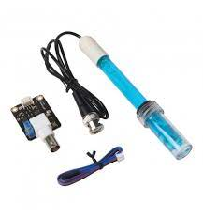

Figure 1: pH sensor used.

Temperature sensor - Sensor used to monitor water and air temperature to ensure it is in the optimal range for plant growth. This sensor can particularly be use can measure temperatures from −55 °C to 125 °C with an accuracy of ±0.5 °C. There are different temperatures required for different plants, therefore it depends entirely on what plant is used before establishing the temperatures needed. Ensuring the temperature remains constant and does not spike to affect plant health.

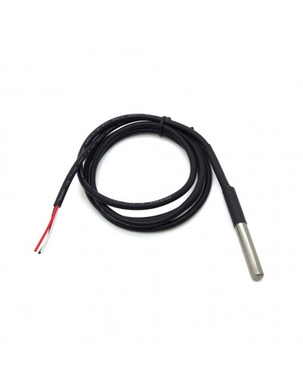

Figure 2: Waterproof temperature sensor.

Water level sensor – Using this to ensure water levels are adequate in the water tank. The system only needs 10% to 16% of the water required for the plant to grow (Venter, 2017). The water level sensor is still important to accurately ensure the level remains adequate.

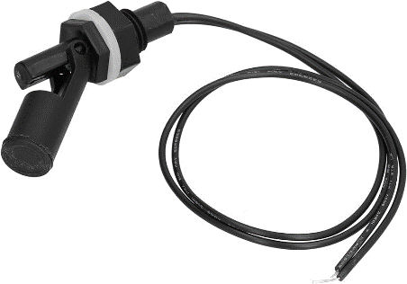

Figure 3: Water level sensor.

## Wi-Fi Connectivity

Different Arduino boards come with built in Wi-Fi capabilities. For example, the MKR family supports IoT applications, sensor networks and cloud connectivity. The Nano family also generally supports Wi-Fi connectivity though might have more power restrictions. Arduinos that support Wi-Fi connectivity will generally range from $20-$50. There are also third-party Wi-Arduino Fi Shields available that can provide Wi-Fi connectivity to other Arduino boards. These generally will run $10-$20 but will also require soldering and extra coding to get the systems working (Chris, 2021).

## Electrical compliance and cable management

Ensuring electrical safety and effective cable management is very important to safeguard everyone who will be working on or using the system. Electricity poses inherent risks and by implementing rigorous cable management practices, we prioritize safety and minimize potential hazards​ (Rebortson, 2023)​.

## How will we work with other subsystems?

**Collaboration between Team Electro and Team Photon:**

* Team Electro leads the implementation of an automation system for managing LED grow lights. This involves purchasing pre-programmed sensors to control lighting schedules based on plant growth stage and sunlight levels. Collaborating closely with Team Photon, they ensure seamless integration of chosen LED lights and the automation system to meet plant needs.
* Team Electro incorporates sensors monitoring light spectrum and intensity to enhance plant development. Collaborating with Team Photon, they choose appropriate sensors and integrate them into the lighting system for accurate and reliable measurements.
* Team Electro prioritizes energy efficiency in the lighting system, using methods like pulsing or dimming LEDs to save energy while maintaining optimal light levels for plants. They will collaborate with Team Photon to select energy-efficient LED lights and explore alternative power sources such as solar panels to reduce environmental impact.

**Collaboration between Team Electro and Team Hydro:**

* Team Electro and Team Hydro collaborate closely to ensure accurate nutrient delivery by managing pumps and valves. The integration of the water pump is critical; Team Hydro has experience with flow rate requirements, while Team Electro selects and integrates sensors for efficient control. Together, they optimize nutrition supply and enhance system performance.
* Team Electro integrates sensors to measure pH and electrical conductivity (EC) levels in the nutrient solution, providing real-time feedback on acidity and nutrient content. Collaborating with Team Hydro, they develop algorithms and calibrate sensors to adjust nutrient concentrations and maintain ideal pH and EC values for plant development.
* Team Electro creates the hydroponics system's user interface, which may include a database or website, enabling users to access warnings, system modifications, and sensor data. They collaborate closely with Team Hydro to ensure the UI remains user-friendly and intuitive for teachers and students.

# Conclusion

In conclusion, the incorporation of hydroponics to Spa Park Primary School offers a noteworthy chance to tackle issues related to food production while negotiating environmental and cultural concerns. The potential of hydroponics to transform agriculture, especially in urban environments like Bela-Bela, is shown by its historical progression from antiquated traditions to contemporary technical breakthroughs. Nonetheless, a few elements, such as power supplies and sensor management, must be carefully considered before using hydroponics in this situation.

Hydroponic systems in South Africa have difficulties due to load shedding, which calls for creative alternatives like solar energy to maintain continuous operation. It needs cooperation between the teams—Electro, Photon, and Hydro, for example—to smoothly integrate different components and maximize system performance. Wi-Fi connectivity, electrical compliance, and efficient sensor management are essential for guaranteeing the hydroponics system's safety, effectiveness, and user-friendliness.

The effective use of hydroponics at Spa Park Primary School suggests favourably for improving food security, encouraging sustainability, and cultivating learning opportunities for pupils. We can create the foundation for a better, more sustainable future in Bela-Bela and beyond by tackling the current issue with creative ideas and teamwork.

# References

* Chris. “Arduino with WIFI: A How-to Guide for Adding and Using.” Chip Wired, Chip Wired, 18 Nov. 2021, chipwired.com/arduino-board-wifi-guide/.
* Growee Smart Hydroponics. (2022). What is the Ideal Water Temperature for Hydroponics? | Growee. [online] Available at: https://getgrowee.com/ideal-water-temperature-for-hydroponics/.
* Farmer’s Weekly. (2017). Hydroponic water requirements. [online] Available at: https://www.farmersweekly.co.za/agri-technology/farming-for-tomorrow/hydroponic-water-requirements/.
* Lane Catherine. (2024). How much power does a solar panel produce?.
* Abu Sneineh, A. and Shabaneh, A.A.A. (2023). Design of a smart hydroponics monitoring system using an ESP32 microcontroller and the Internet of Things. MethodsX, [online] 11, p.102401. doi:https://doi.org/10.1016/j.mex.2023.102401.
* Erchen, A., 2023. Agriculture & agribusiness: The Impact of Load shedding on Agriculture in South Africa.
* World Standards2024 South Africa - Power plug, socket & mains coltage in South Africa. [Online]
* Available at: https://www.worldstandards.eu/electricity/plug-voltage-by-country/south-africa/#:~:text=230%20V%20~%2050%20Hz&text=South%20Africa%20initially%20standardized%20on,sockets%20can%20still%20be%20found.